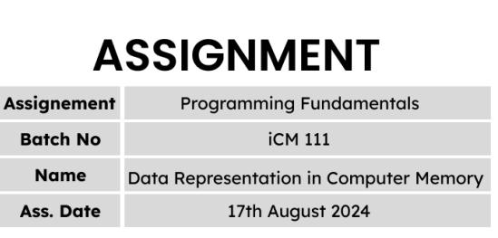

////////////////////////////////////////Q 1//////////////////////////////////////////

A & B

////////////////////////////////////////Q 2//////////////////////////////////////////

B

////////////////////////////////////////Q 3//////////////////////////////////////////

1. 3
2. -3
3. 3
4. -3
5. 3
6. -3
7. 3

////////////////////////////////////////Q 4//////////////////////////////////////////

1. 17
2. -10
3. -17
4. -3
5. 7
6. -3

////////////////////////////////////////Q 5//////////////////////////////////////////

-100

100

-100

-200

400

0

////////////////////////////////////////Q 6//////////////////////////////////////////

100101

104

104

////////////////////////////////////////Q 7//////////////////////////////////////////

101 100

102 101

103 102

////////////////////////////////////////Q 8//////////////////////////////////////////

101 101

102 102

103 103

////////////////////////////////////////Q 9//////////////////////////////////////////

100

101

102

104

105

106

////////////////////////////////////////Q 10//////////////////////////////////////////

1. The output is 30 (10 + 20 = 30)
2. The output is -10 (10 + (-20) = -10)
3. ++a = 11 and it is pre-increment operator so the output is 31
4. b’s actual value is 21(It is created in ram) but b is post-increment operator. So b = 20 and the output is 30.
5. a’s and b’s actual value respectively 11 and 21. a is a pre-increment operator and b is a post-increment operator. So a = 11 and b = 20 and the output is 31.
6. a’s and b’s actual value respectively 11 and 21. a and b are post-increment operators. So a = 10 and b = 20 and the output is 30.
7. a’s and b’s actual value respectively 11 and 21. Those are pre-increment operator . So the output is 32.
8. a’s and b’s actual value respectively 11 and 21. a is a post-increment operator and b is a pre-increment operator. So a = 10 and b = 21 and the output is 31.

////////////////////////////////////////Q 11//////////////////////////////////////////

12-4*2 :4 – According to the operator precedence, first 4 multiply by 2 and after that do 12 subtract by 8

(12-4)*2 :16 – According to the operator precedence, first solve the inside of the parentheses and after multiply by 2 (8 * 2 = 16)

12-(4*2):= 12 – 8= 4

////////////////////////////////////////Q 12//////////////////////////////////////////

1. x = 7 % 10 / 2 * 2

x = 7 / 2 * 2

x = 3 * 2

x = 6

1. x = 7 % (10 / 2) * 2

x = 7 % 5 * 2

x = 2 * 2

x = 4

1. x = 7 % 10 / (2 * 2)

x = 7 % 10 / 4

x = 7 / 4

x = 1

1. x = 7 % (10 / (2 * 2))

x = 7 % (10 / 4)

x = 7 % 2

x = 1

1. x = 7 % ((10 / 2) * 2)

x = 7 % (5 * 2)

x = 7 % 10

x = 7

////////////////////////////////////////Q 13//////////////////////////////////////////

import java.util.*;

class Example{

public static void main(String args[]){

int remainder, quotient;

Scanner input = new Scanner(System.in);

System.out.print("Enter the dividend number : ");

int dividend = input.nextInt();

System.out.print("Enter the divisor number : ");

int divisor = input.nextInt();

quotient = dividend / divisor;

System.out.println("quotient = " + quotient);

remainder = dividend % divisor;

System.out.println("remainder = " + remainder);

}

}

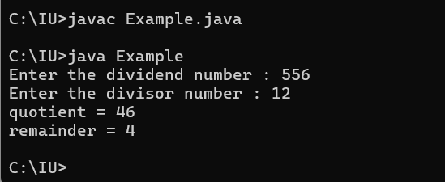

////////////////////////////////////////Q 14//////////////////////////////////////////

import java.util.*;

class Example{

public static void main(String args[]){

int addition, subtraction, multiplication, division;

Scanner input = new Scanner(System.in);

System.out.print("Enter the first number : ");

int num1 = input.nextInt();

System.out.print("Enter the second number : ");

int num2 = input.nextInt();

addition = num1 + num2;

System.out.println("addition = " + addition);

subtraction = num1 - num2;

System.out.println("subtraction = " + subtraction);

multiplication = num1 * num2;

System.out.println("multiplication = " + multiplication);

division = num1 / num2;

System.out.println("division = " + division);

}

}

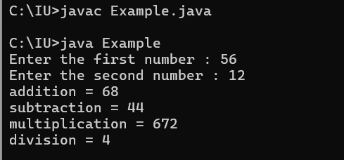

////////////////////////////////////////Q 15//////////////////////////////////////////

import java.util.*;

class Example{

public static void main(String args[]){

double area, perimeter;

Scanner input = new Scanner(System.in);

System.out.print("Enter the radius of circle : ");

double r = input.nextDouble();

area = Math.PI * r * r;

perimeter = 2 * Math.PI * r;

System.out.println("Area of the circle = " + area);

System.out.println("Perimeter of the circle = " + perimeter);

}

}

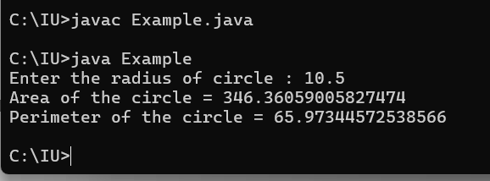

////////////////////////////////////////Q 16//////////////////////////////////////////

import java.util.*;

class Example{

public static void main(String args[]){

double discount, new_price;

Scanner input = new Scanner(System.in);

System.out.print("Enter the price of product : : ");

double price = input.nextDouble();

System.out.print("Enter the discount rate of percentage : ");

double rate = input.nextDouble();

discount = price * rate / 100;

System.out.println("Discount price = " + discount);

new_price = price - discount;

System.out.println("New price of the product : " + new_price);

}

}

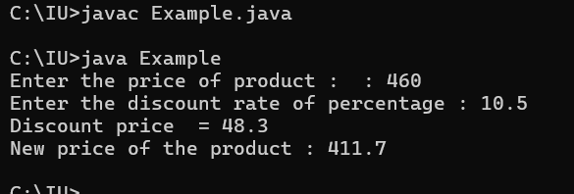

////////////////////////////////////////Q 17//////////////////////////////////////////

import java.util.*;

class Example{

public static void main(String args[]){

double tax, new_price;

Scanner input = new Scanner(System.in);

System.out.print("Enter the price of products : : ");

double price = input.nextDouble();

tax = price * 15 / 100;

System.out.println("tax = " + tax);

new_price = price + tax;

System.out.println("New price of the product : " + new_price);

}

}

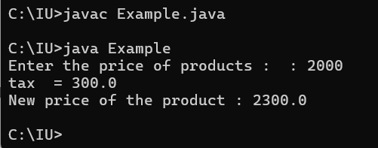

////////////////////////////////////////Q 18//////////////////////////////////////////

import java.util.*;

class Example{

public static void main(String args[]){

double KB, MB, GB;

Scanner input = new Scanner(System.in);

System.out.print("Enter the amount bytes : : ");

double bytes = input.nextDouble();

KB = bytes / 1024;

MB = KB / 1024;

GB = MB / 1024;

System.out.println("In Kilo Bytes = " + KB);

System.out.println("In Mega Bytes Bytes = " + MB);

System.out.println("In Giga Bytes = " + GB);

}

}

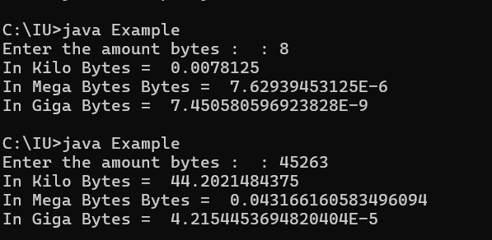

////////////////////////////////////////Q 19//////////////////////////////////////////

import java.util.*;

class Example{

public static void main(String args[]){

Scanner input = new Scanner(System.in);

System.out.print("Enter the number of days : : ");

int days = input.nextInt();

int years = days / 365;

int months = (days - years * 365 ) / 30;

int Days = days - years * 365 - months * 30;

System.out.println(days + " days" + " = " + years + " years " + months + " months " + Days + " days ");

}

}

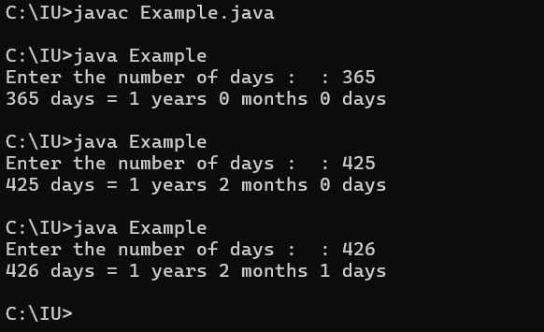

////////////////////////////////////////Q 20//////////////////////////////////////////

import java.util.*;

class Example{

public static void main(String args[]){

Scanner input = new Scanner(System.in);

System.out.print("Enter the number of seconds : : ");

int seconds = input.nextInt();

int hours = seconds / 3600;

int minutes = (seconds - hours * 3600 ) / 60;

int Seconds = seconds - hours * 3600 - minutes * 60;

System.out.println(hours + ":" + minutes + ":" + Seconds);

}

}

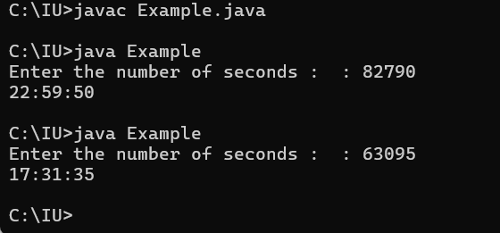

////////////////////////////////////////Q 21//////////////////////////////////////////

import java.util.*;

class Example{

public static void main(String args[]){

Scanner input = new Scanner(System.in);

System.out.print("How many eggs do you have : ");

int eggs = input.nextInt();

int gross = eggs / 144 ;

int dozen = (eggs - gross * 144) / 12;

int Eggs = eggs - gross * 144 - dozen * 12;

System.out.printf("Your number of eggs is %d gross, %d dozen, and %d",gross, dozen, Eggs);

}

}

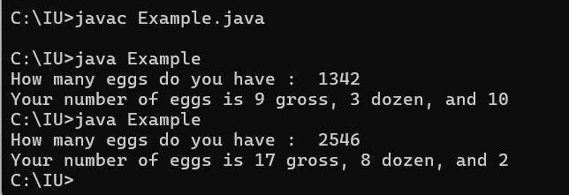

////////////////////////////////////////Q 22//////////////////////////////////////////

import java.util.*;

class Example{

public static void main(String args[]){

Scanner input = new Scanner(System.in);

System.out.print("Enter number 1 : : ");

int num1 = input.nextInt();

System.out.print("Enter number 2 : ");

int num2 = input.nextInt();

int mod = num1 / num2;

int remainder = num1 - num2 * mod;

System.out.printf("Remainder = % d " , remainder);

}

}

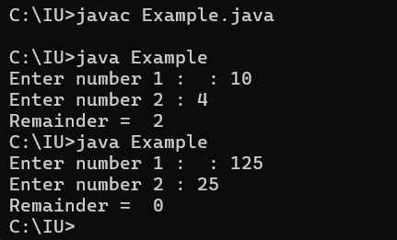

////////////////////////////////////////Q 23//////////////////////////////////////////

import java.util.*;

class Example{

public static void main(String args[]){

Scanner input = new Scanner(System.in);

System.out.print("Enter body mass in kilograms : : ");

float mass = input.nextFloat();

System.out.print("Enter height in meters : ");

float height = input.nextFloat();

double bmi = mass / (height * height);

System.out.printf("Body Mass Index(BMI) is % f " , bmi);

}

}

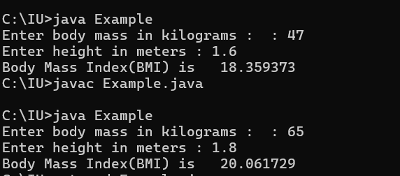

////////////////////////////////////////Q 24//////////////////////////////////////////

import java.util.*;

class Example{

public static void main(String args[]){

Scanner input = new Scanner(System.in);

System.out.print("Enter basic salary : : ");

double salary = input.nextDouble();

double employee_fund = salary * 12 / 100;

System.out.printf("Employee Fund = % f \n" , employee_fund);

double employer_fund = salary * 3.5 / 100;

System.out.printf("Employer Fund = % f \n" , employer_fund);

double pension = salary * 8.3 / 100;

System.out.printf("Pension Fund = % f \n" , pension);

}

}

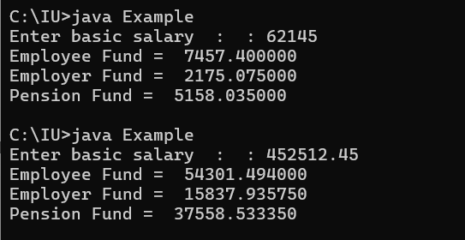

////////////////////////////////////////Q 25//////////////////////////////////////////

import java.util.*;

class Example{

public static void main(String args[]){

Scanner input = new Scanner(System.in);

System.out.print("Enter the tax-inclusive price in dollars : : ");

double price = input.nextDouble();

double actual_price = price * 100 / 110 ;

double tax = price - actual_price;

System.out.printf("Actual price is: $%.2f \n" , actual_price);

System.out.printf("Sales Tax is: $%.2f \n" , tax);

}

}

